**CHAPTER 1**

**INTRODUCTION**

* 1. **Background:**

With the rapid development of information technology, the network has brought great convenience to people, where people are willing to get lots of information. However, the great security of information has become increasingly serious. There are many applications including online banking, e-commerce, as well as national security and so on, which are in urgent need of effective identification technology to protect the user’s security. Compared with the traditional identity authentication technology, the identity authentication technology based on biometrics is more efficient, convenient and safe, which cannot only meet the basic security need of citizens, but also play a vital role in national information security.

At present, the recognition technology of biometric characteristics mainly uses computer vision, graphics and image processing, pattern recognition and other techniques to extract human characteristics, including physiological characteristics and behavior characteristics. The physiological characteristics that can be detected and verified are fingerprint, iris, retina, facial features, etc. and behavioral characteristics of voice, gait, handwriting, etc. Compared with fingerprint and iris, face recognition is non-contact recognition technology with a higher nature acceptability and intuition.

Face is the most important attributes in human beings which is used for its identification and for conveying emotions in its social life. Human can easily recognize the face that had been seen if the face is remembered. Despite of large variation in visual stimulus due to changing condition and distraction such as beard, glasses or change in hairstyle, human can easily recognize the face. This is due to high degree of interconnectivity, adaptive nature, learning skills and generalization capabilities of human nervous system which is composed of highly interconnected neurons.

In case of computer, detection and recognition of face is one of the most challenging problems. It is because, in computers there doesn’t exist a nervous system like human and isn’t capable of adaptive nature. Also, computer requires more complex algorithms for interconnectivity between its various components. Moreover, computer needs system software for detection and recognition of human face. That is why, detection and recognition of face for machine like computer is very much difficult.

Face detection is a computer technology being used in a variety of applications that identifies human faces in digital images. Face detection also refers to the psychological process by which human locate and attend to faces in a visual scene. It can be regarded as a specific case of object-class detection. In object-class detection, the task is to find the locations and sizes of all objects in an image that belong to a given class. Face detection algorithm focus on the detection of frontal human faces. Face detection involves separating image windows into two classes; one containing faces and other containing the background. It is difficult because although commonalities exist between faces, they can vary considerably in terms of age, skin color, pose and facial expression. The problem is further complicated by differing lightening conditions, image quality and geometrics [2].

Face recognition is one of the most relevant applications of image analysis. A facial recognition system is a computer application capable of identifying or verifying a person from a digital image or a video frame from a video source. It’s a true challenge to build an automated system which equals human ability to recognize faces. Although humans are quite good identifying known faces, we are not very skilled when we must deal with a large amount of known faces [3]. The computers, with an almost limitless memory and computational speed, should overcome human limitations.

Currently, reliable face detection and recognition are becoming more important on mobile devices. E.g. to unlock the screen. However, using only frontal face images for authentication purposes can no longer be considered secure under the assumption of easy availability of frontal snapshots of the respective device owners from social network or other media. Current results to face detection are promising, but reliable face recognition needs further research.

* 1. **Motivation:**

Face detection and recognition is a challenging problem which has received much attention during recent years due to its many applications in different fields. We consulted many friends, teachers and seniors as well as pursued various similar documents online on the process of determining a satisfying and suitable project. We realized that face detection and recognition project is good for this level. Also, our senior who had previously built this system recommended on developing a similar project, and all of these motivated us to build this project.

* 1. **Statement of Problems**

After making case study on systems related to face detection and recognition, we noted down some of the problems that are faced in the past projects. The foremost problem that the existing systems are bounded with is to detect a face of an individual accurately. Secondly, they had got problem in the recognition of the face in an image. Other problems in the past projects are:

* Identify one or more persons in the scene.
* Variation introduces in a pattern of the face makes the face recognition task more difficult.
* Problem in preprocessing the image.
* AI learning problems.
* Problem in implementation of algorithm.
  1. **Objectives**

The main objective of our project is to detect and recognize the face.

* 1. **Applications**

As one of the successful applications of image analysis and understanding, face detection and recognition system has received significant attention, especially during past several years.

There are least two reasons for such a trend: one is due to the wide range of commercial and law enforcement applications and another is due to feasible technological change. That is why this type of system has a wide range of applications in the field of image processing. The major areas of its applications are:

* In the field of biometric security system that use face as the password.
* In the field of education for taking attendance based on face detection and recognition.
* For the identification of criminal.
  1. **Scope**

Nowadays, face detection is used in many places especially in website hosting images like photo bucket, facebook etc. the automatically tagging feature has added a new dimension to sharing picture among the people who are in the picture and also gives the idea to other people about who the person is in the image. This has become possible due to development of face detection and recognition system. Moreover, it can be efficiently implemented in the education institute for making attendance and storing the information, in identifying the criminals, in the field of information security etc. thus, the scope of this project is very high.

* 1. **Limitations**

Like any other systems, our system also has few limitations which are discussed below:

* **Accuracy:**Accuracy is the important factor for the success of any project. Though, no software has 100% accuracy, we have tried to maintain the accuracy of the system as high as possible. However, the accuracy of face detection and recognition is limited by the underlying algorithm and the quality of image being processed.
* **Operational Constraints:**

Although, we had claimed that our system would classify any image on the basis of identity of individual in it, it has some operational constraint, one of the major constraint are the alignment of face and illumination. Our system fails to recognize misaligned faces and poorly illuminated images.

* **Limited Processing Speed:**

The system’s operating speed largely depends on the algorithm chosen as well as the efficiency of the computer system in which it is deployed. Our system’s processing speed is limited by the underlying computer hardware as well as the library function of OpenCV.

**CHAPTER 2**

**LITERATURE REVIEW**

**Review of Literature**

In reviewing the literature on a topic “Face Detection and Recognition system” on number of research papers, we found that face recognition is a juvenile field for research and development that has received much attention during recent years due to its many applications. Face detection is a computer technology being used in a variety of application that identifies face in digital image. Face detection also prefers to the psychological process by which human locate and attend to faces in a visual scene. Face detection can regarded as a specific case of object-class detection. In object-class detection, the task is to find the location and sizes of all objects in an image that belongs to a given class.

According to Paul Voila, Micheal J Jones: international journal of computer vision, pp.137-154, Netherlands (2004), there are many face detection techniques to locate a human face in a scene [1]. Some of them are:

* KNOWLEDGE BASED METHODS:

In this method, knowledge about facial information such as eyes, nose, and mouth are used for detection of face.

* FEATURE INVARIENT METHODS:

In these methods of face detection facial feature such as texture, skin color, facial expression etc. are used for detection of face by making comparison of facial invariant features from database with those after capturing the face image.

* TEMPLATE MATCHING METHODS:

Template matching is a technique in digital image processing for finding small parts of an image which match a template image.

* APPEARANCE BASED METHODS

This methods employs Eigen faces, neural networks, support vector machine or hidden markov models for detection of face. Here, the model learns detection of face from a set of training images which should capture the representative variability of facial appearance.

According to Hyeonjoon Moon, Department of Computer Engineering, state university of New York at buffalo (2005), there are many paradigms available for implementing the recognition [4]. Some of them are:

* GEOMETRIC FEATURE BASED MATCHING:

The basic idea behind this algorithm was to describe the overall configuration of the face by a vector of numerical data representing the relative position and size of main facial features: eye and eyebrows, nose and mouth.

* EIGEN FACES:

Eigen faces are a set of ortho normal basis vectors computed from a collection of training face images. That is, a normal Eigen face vector derived from the gallery of face image and in this facial information is mapped for recognition. They provide a basic flow dimensional representation of the facial images.

* SUPPORT VECTOR MACHINES:

Support vector machines (SVM’s) is binary tree recognition for multi-class recognition. It implement the face recognition process as a binary pattern-classification task i.e. the content of a given part of an image is transformed into features , after which a classifier trained on example faces decides whether that particular region of the image is a face or not.

* NEURAL NETWORK

The idea of neural network came from the neural structure of the human brain. An artificial neuron is created that collects facial information from the image and uses them for recognition. A modern neuron consists of multiple inputs and a single output. A neural network learning algorithm called back propagation is among the most effective approaches to machine learning for face recognition system [4]. This method acquires the training information from the training process and implements this training information in test process for recognition of face.

C.M. Bishop Thesis was about various approaches for 2D face recognition. According to this thesis, the task of face recognition can be classified in three categories and are analytic (feature based), holistic (global), and hybrid method [2]. Thesis gave a framework for facial expression recognition that can effectively maximize information gathered about the emotion change and minimize the impact of personal identity. Only expressionless, frontal view faces will be presented to the face detection and face recognition systems. Two issues discussed in theory literature review were:

1. Right combination of an algorithm

2. The features of design of classifiers

According to Mathew A. Turk, Alex P. Pentland, Proc IEEE conference on Computer Vision, there are three techniques of face recognition and those techniques are:

* Appearance based FR
* Model based FR
* Techniques using Neural Network

We also found that our seniors had also accomplished the task of designing “FDRS” as their final year project work. In reviewing literature on their project report, we know the detection and recognition techniques they had implemented. According to PCA algorithm was implemented for face recognition process. However the problem faced were difficulties in deriving facial features accurately. Besides this, they have got the problem of creating Eigen face vector. Moreover, it became very hard to implement PCA algorithm for recognition of face.

The problems that our seniors had faced, according to Bikram Shrestha, Biplav Raj Osti, Nischal Lamichane, Rajesh Sangat, Final Year Project of the Degree of Bachelor in Computeer Engineering, Khwopa Engineering College (2013) [8], Automated Face Detection and Recognition System should be combined into fully automated face detection and recognition system. The face recognition sub-system must display a degree of invariance to scaling and rotation errors in the segmented image extracted by the face detection sub-system.

In summary, reviewing of all these research papers by different people on different algorithms for face detection and recognition system was of great assistance for us. We studied these documents along with the technical documentations of few commercial face recognition system and we had tried to develop an effective and efficient face detection and face recognition system for information management.

**CHAPTER 3**

**PROJECT MANAGEMENT**

Time and resource management are the two most important things to be considered for developing an effective project. Beside this, team must be formed and work load must be divided among the team members. To complete the task of developing information management system using face detection and face recognition successfully in a proper managed way and present it in time. We formed a team of four members.

**3.1 Team Members**

1. Bina Kandel (0720311)
2. Sajid Shrestha (0720337)
3. Sameer Khadka (0720338)
4. Sujan Katwal (0720346)

**3.2 Gantt chart**

The expected time for completion of the project is shown in Gantt chart.

|  |  |  |  |  |  |  |  |
| --- | --- | --- | --- | --- | --- | --- | --- |
| S.N | Week  Strategies | 1st week | 2ndweek | 3rd week | 4th week | 5th week | 6th week |
| 1) | Research and analysis |  |  |  |  |  |  |
| 2) | Establishing Goals |  |  |  |  |  |  |
| 3) | Design a model |  |  |  |  |  |  |
| 4) | Coding and Debugging |  |  |  |  |  |  |
| 5) | Implementation & testing |  |  |  |  |  |  |
| 6) | Documentation |  |  |  |  |  |  |

Table 3.2: Gantt chart of the project

**CHAPTER 4**

**METHODOLOGY**

**Principle:** In our project we use color image to grey image conversion technique and Haar cascade classifiers to detect the face and LBPH to recognize the face.

In [LBPH](http://en.wikipedia.org/wiki/Local_binary_patterns) each images is analyzed independently. We characterize each image in the dataset locally; and when a new unknown image is provided, we perform the same analysis on it and compare the result to each of the images in the dataset. The way which we analyze the images is by characterizing the local patterns in each location in the image.

* 1. **Block Diagram**

Camera

Training Process

Haar Cascade Based Face Detector

Face Image Acquisition

Face Image

Preprocessing

Training Info

Detected Face

LBPH Based Face Recognizer

Equivalent Face Image

Known Face

Fig 4.1: Block Diagram of the System

* 1. **Flowchart for LBP Process**

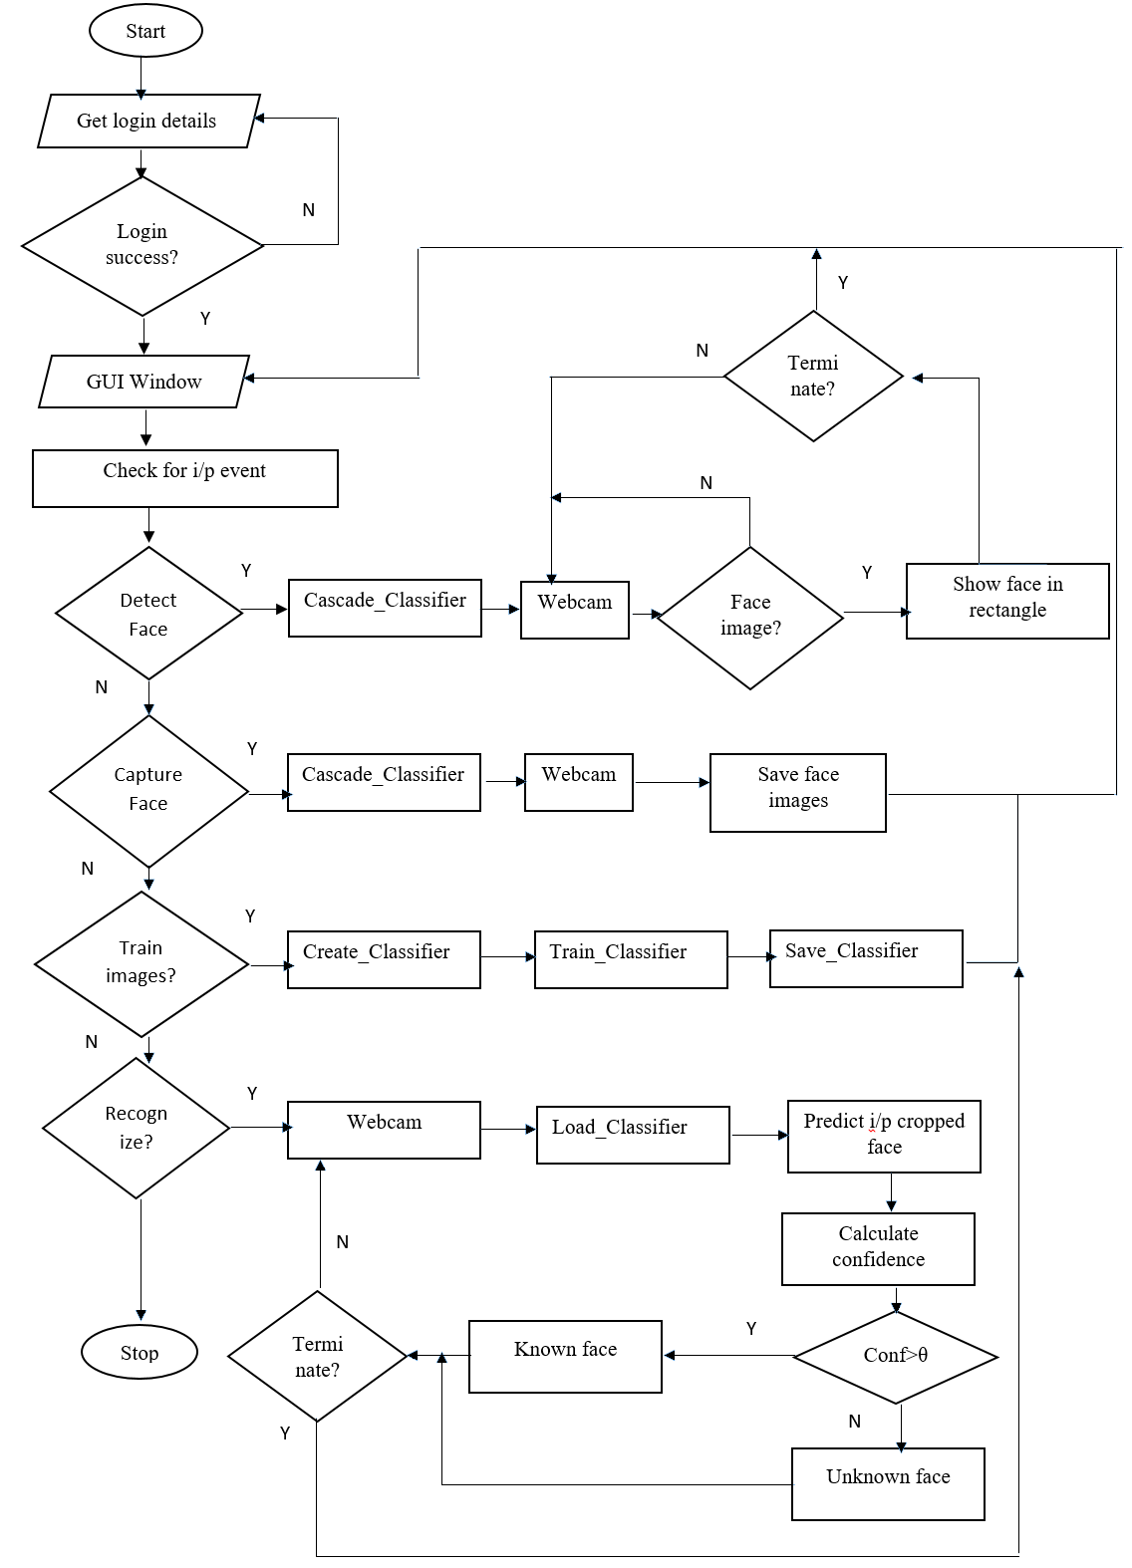

Fig 4.2: Flowchart of the system

**4.3 Algorithm**

**LBPH Algorithm description:**

A more formal description of the LBP operator can be given as:

LBP(xc,yc)=ps(ip-ic)

Here the (xc , yc) is central pixel with intensity ic and ip being the intensity of the neighbor pixel and s is the signum function which is defined as:

(1)

if x

s(x) =

This description enables us to capture very fine grained details in images. The idea is to align an arbitrary number of neighbors on a circle with a variable radius, which enables to capture the following neighborhoods:

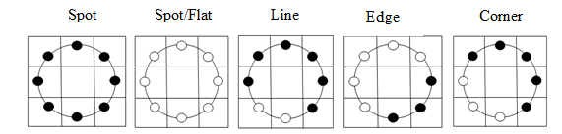

For a given point (xc , yc) the position of the neighbor (xp ,yp),  can be calculated by:

xp= xc+ Rcos

yp= yc- Rsin

Where R is the set of radius of the circle and P is the number of sample points.

The operator is an extension to the original LBP codes, so it’s sometimes called Extended LBP (also referred to as Circular LBP). If a point’s coordinate on the circle doesn’t correspond to image coordinates, the point gets interpolated. Computer science has a bunch of clever interpolation schemes, the OpenCV implementation does a bilinear interpolation:

f(x, y)

**4.4 Tools & Platforms**

Thus, the various tools and platform that we will use for developing this system are:

* Camera as a capturing device
* Python as a platform for coding
* MS-Excel for storing information

**CHAPTER 5**

**RESULT AND DISCUSSION**

**5.1 Testing:**

System testing is a process of executing of program with the intent of finding errors. The purpose of testing is to show that a program performs its intended function correctly. That is, testing involves validating that the system whether it meets the designated functional and non-functional requirements. There are different ways to conduct system testing. During implementation phase, module are informally tested by the programmer while they are being coded. After the programmer is satisfied that the module appears to function correctly, methodical testing of the testing is undertaken by a separate testing team.

Although software testing is itself an expensive activity, launching of software without testing may lead to cost potentially much higher than that of testing. That’s why, after completion of our project, we carried the testing work. The testing is done to analyze software with the intent of finding errors. Here the program was executed in a control manner to answer the question: Does the software behave as specified? Hence, the testing was done to develop a quality software product.

Therefore, while developing our system, different types of testing was performed such as unit testing, module testing, alpha testing, beta testing and finally system testing. However, to make effective study about testing, work is to classify the testing process into two types. They are black-box testing and white-box testing.

**5.1.1 White-Box Testing:**

In this type of testing, test cases are applied to test whether the design system can meet the desired requirements or not. This integrate unit testing and module testing. Moreover, alpha testing was also included. Beside this about 200 images called trained images where inputted and tested whether the system recognize the inputted test image or not.

**5.1.2 Black-Box Testing:**

In this type of testing, FDRS was provided to friends, teachers, supervisor and other people for finding the bugs. Here the performance issues was attempted to identify. Besides this, the incompleteness and inconsistency of system with the implied requirements was encopresis.

**5.2 Test Case for Face Detection**

A test case is a set of conditions or variables under which a tester will determine whether an application, software system or one of its feature is working as it was originally established to do or not. That is, test case employs some set of values in order to specify whether the developed system meets the targeted goal or not. In this project, there are various test cases as below.

**5.2.1 Test Case 1 (Different Position of Face)**

For the test to detect the face, six images of face with different position as shown in the figure below was chosen and inputted. Also, the result of testing for detection of face with different face location in the face images where discussed as follows:

**CHAPTER 5**

**REFERENCES**

**Paper in Conference**

[1] Matthew A. Turk, Alex P. Pentland, “Face Recognition Techniques”, Proc IEEE Conference on Computer Vision and Pattern Recognition (1998).

**Report**

[2] HiraShrestha, Manish Budathoki, Samir Dangal, SarojChakradhar, “Face Detection and Recognition System”, Final Year Report of the degree of Bachelor in engineering in Computer Engineering, Khwopa Engineering College (2015).

[3] AwanishRanjan, Bahadur Singh Baniya, Binod Raj Pathak, “Face Recognition System”, Final Year Report of the degree of Bachelor in engineering in Computer Engineering, Khwopa Engineering College (2006).

**Website**

[4] Sanner, S. “Rowley-Baluja-Kanade Face Detector”.

Available at:*http://www.cs.toronto.edu/~ssanner/Software/Vision/Project.html*

[Visited Date: 12th December 2018]

**APPENDIX**

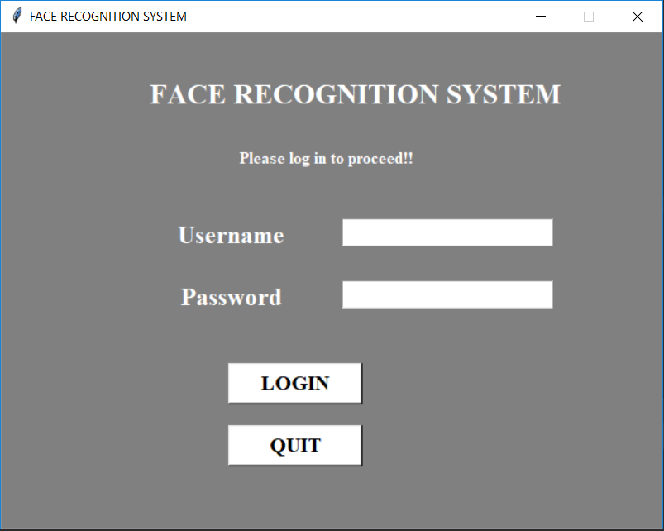

Appendix A: Login Page

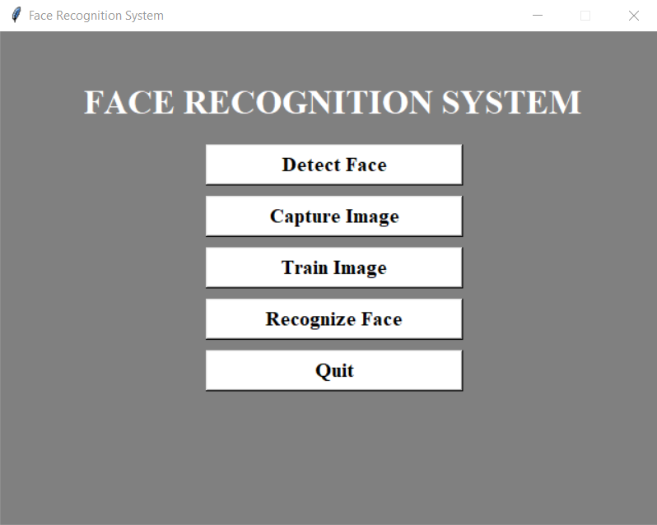

Appendix B: Main Window

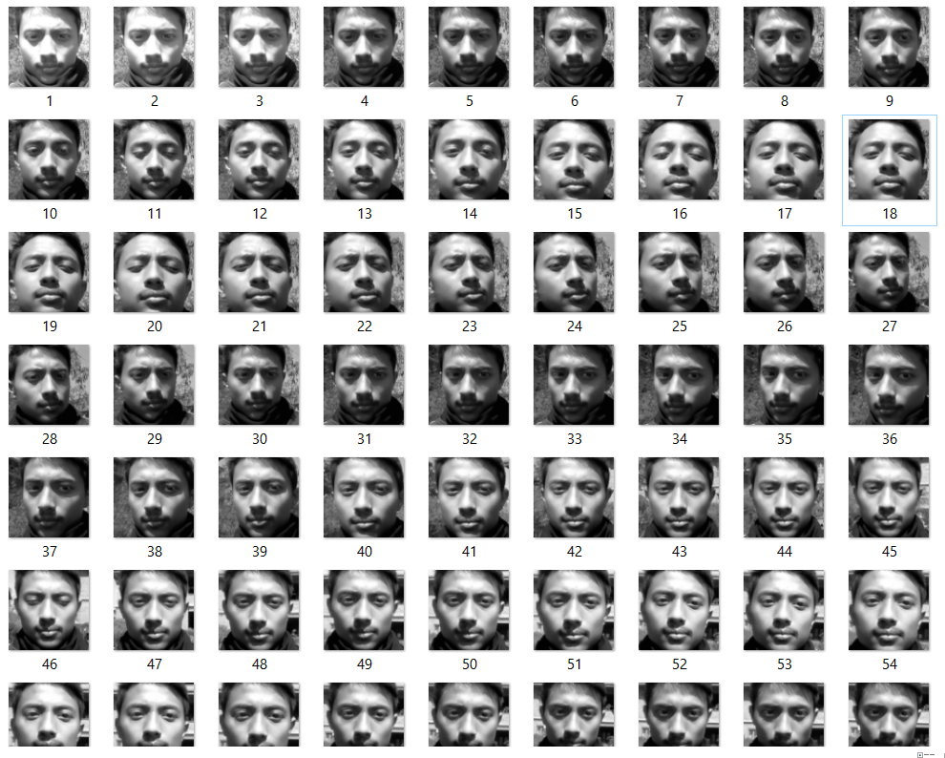

Appendix C: Stored data sets

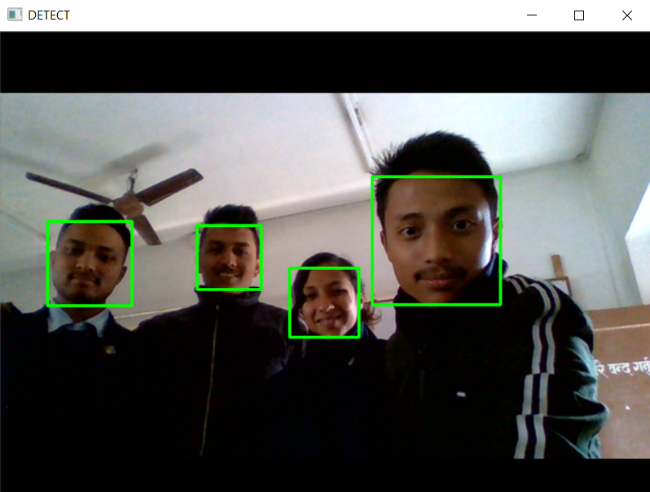

Appendix D: Face Detection